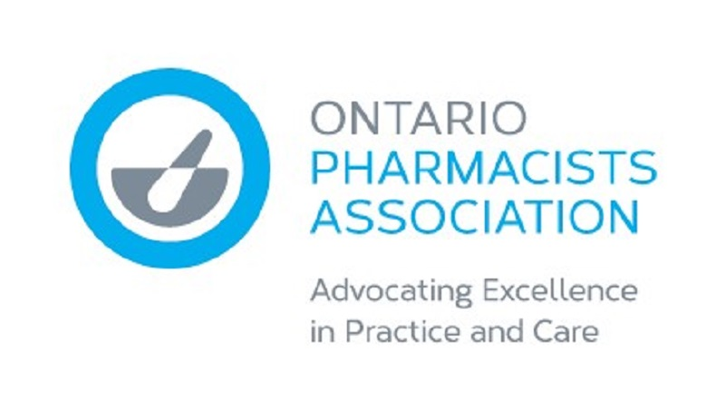

**OPA Statement on 30-Days’ Supply**

**OPA CEO, Justin Bates**:  “Ontario pharmacy professionals are healthcare providers on the front-lines of the COVID-19 pandemic. Recently, many of the provinces across Canada implemented a temporary 30-day supply recommendation to protect and maintain Canada’s drug supply chain as a mechanism to mitigate current shortages and avoid potential supply disruptions downstream. Global drug shortages have been prevalent even before COVID-19. Now, amidst the growing public uncertainty stemming from the pandemic, we must be proactive in ensuring that all Ontarians – and Canadians – have continued access to the medications they need. Collectively, we agree that patients should not have to endure any additional financial burden. Pharmacists appreciate that this may introduce a temporary albeit necessary inconvenience for some patients to ensure their continuity of care. Pharmacists and pharmacy technicians are in a difficult position explaining these changes to patients, despite a stressful workload, and to find workable solutions for those with whom this presents a significant hardship. OPA is urging the Ontario government to immediately implement an interim suspension of any additional copayments to Ontario Drug Benefit recipients stemming from the need to move to 30-day supplies on medications. We are also urging all private drug plans and employer groups to consider similar interim suspensions of private insurance copayments and deductibles that result from monthly dispensing.”